# CrowSoft Sprint 2 Report

CSOFT Sprint 2 - Configure VMs - Prototype application

## Stories completed

* Integrate the application with Jenkins to deploy updated code
* Design the CrowSoft Database according to our functional requirements
* Introduce a team collaboration tool
* Install Apache server on Dev to host application
* Install and test ARTIFACTORY for as a binary repository manager
* Deploy and test PERFORMANCE TOOLS on our DEV server
* Deploy and test NUNIT testing software on our Jenkins server
* clone our servers and keep regular backups of the 3 environments, DEV, STAGE & PROD
* Create an up to date document of our current servers and their status
* Add a Jenkins ssh key to rlennon GitHub repository to allow connectivity
* Integrate the GitHub with Jenkins to Poll repository for changes
* Install an application service for our dotnet core application, so that we can access the web application remotely
* Create and deploy the database MySQL script, so we have the tables available to development
* Increase RAM and Processor on the Jenkins server, so that it improves server performance

## Stories that where in progress

* Deploy and test ANSIBLE for automation on the Jenkins server
* Keep documents in order SO THAT relevant information is easy to find.

## Stories that did not start

* Deploy and test SELENIUM on our DEV server
* Add webhook to GitHub to allow Jenkins to trigger build

## Moving Forward

Sprint 2 goals are combined with Sprint 3 goals to finish off infrastructure setup

Burndown Chart

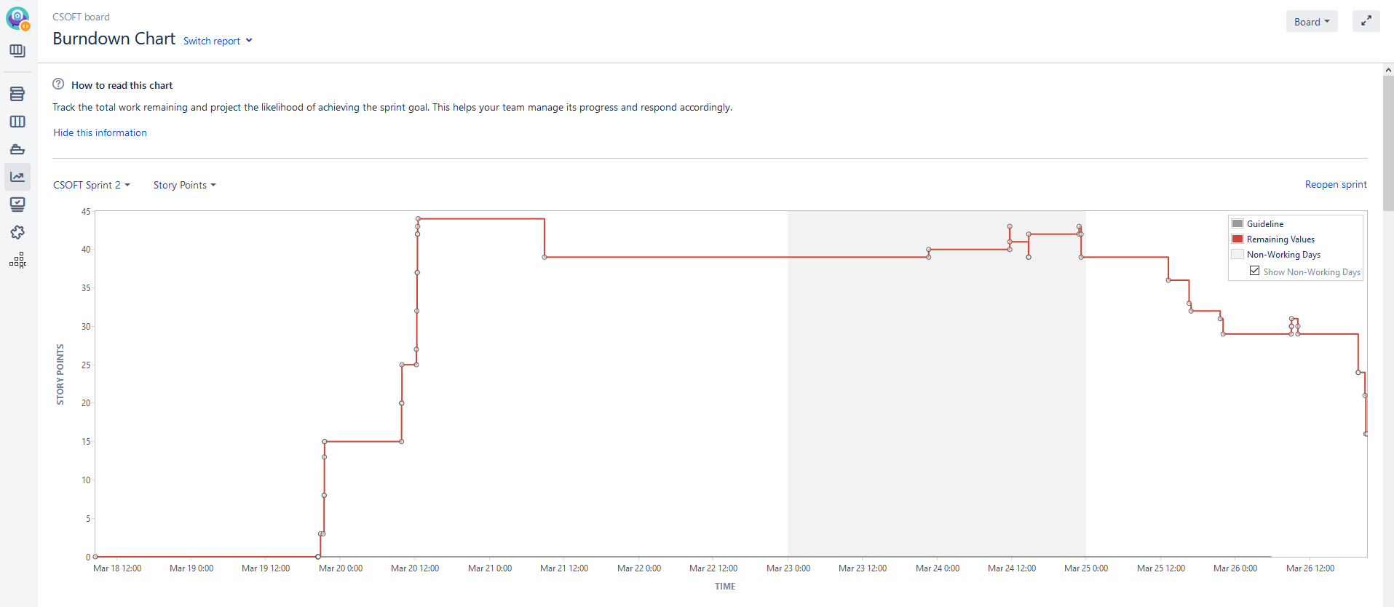

Status report

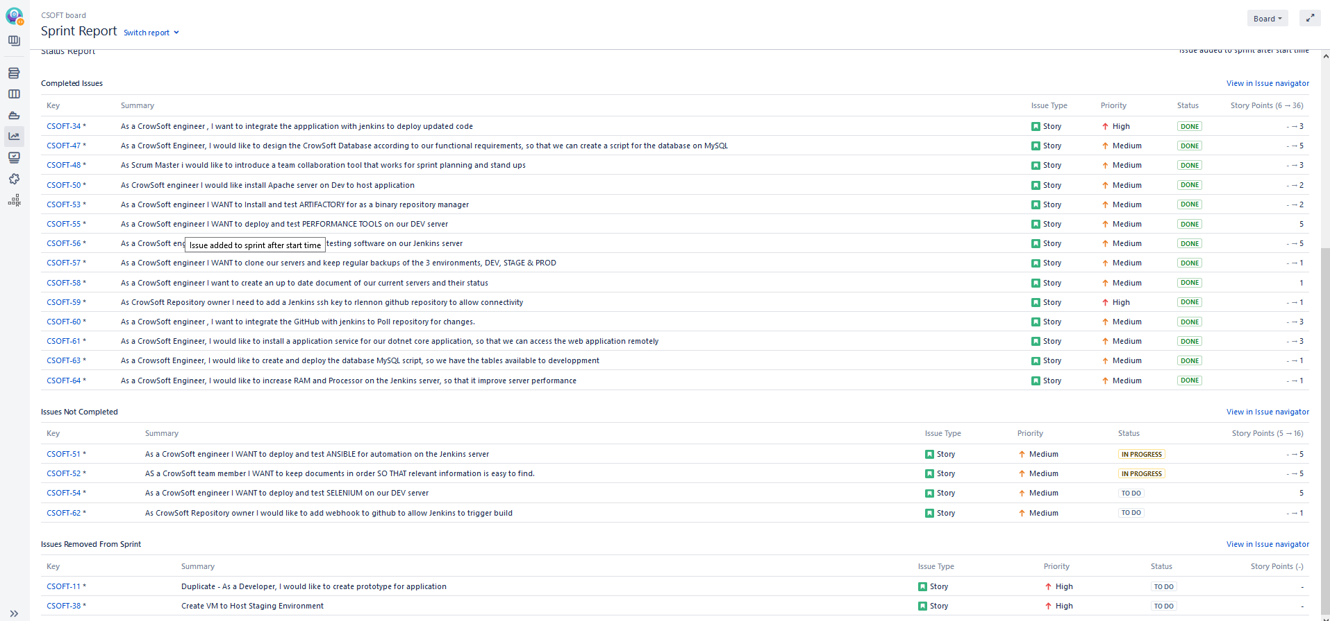

Velocity Chart

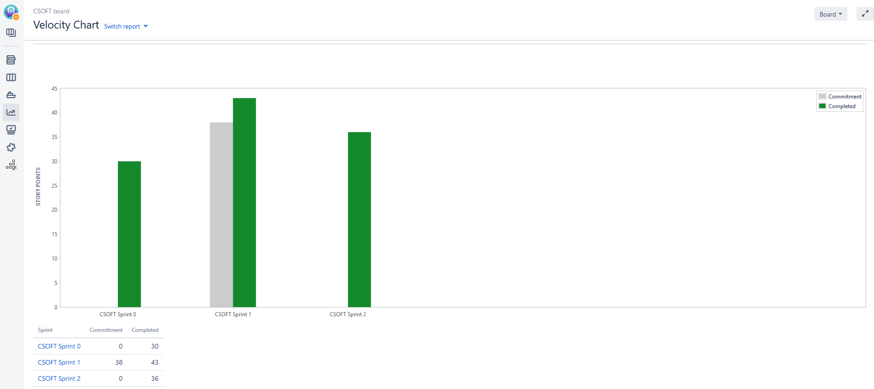

Cumulative flow chart

